[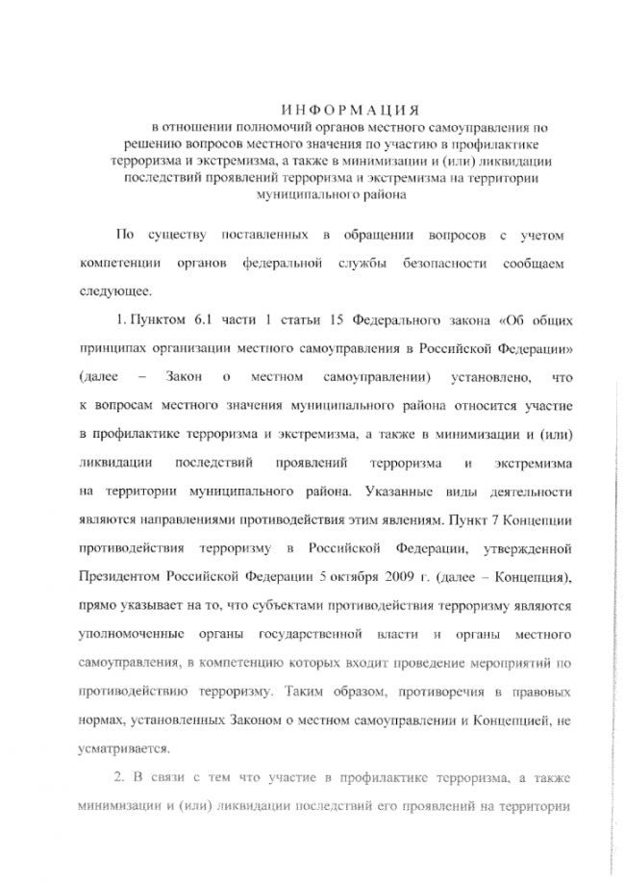](http://грибановский-адм.рф/tinybrowser/fulls/images/photo/2020/11/11/18/27_page-0001-1.jpg)

[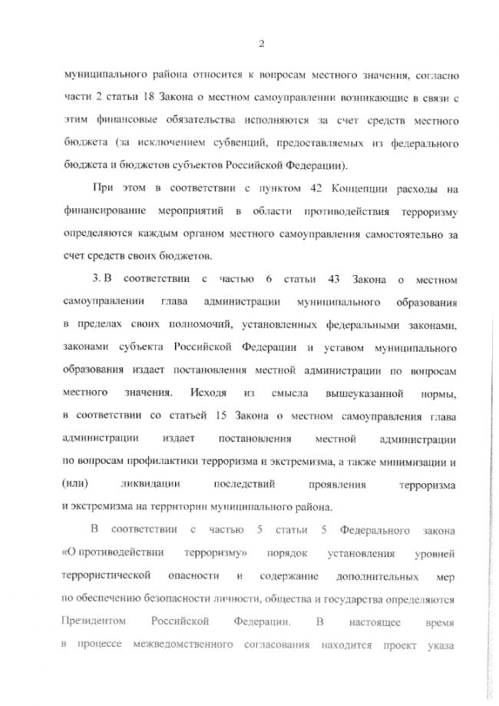](http://грибановский-адм.рф/tinybrowser/fulls/images/photo/2020/11/11/18/27_page-0002-1.jpg)

[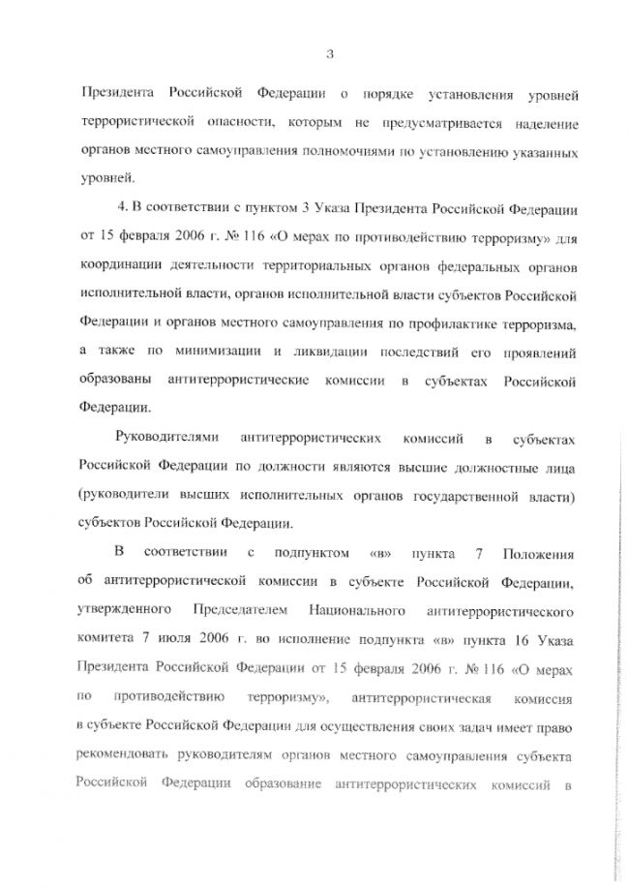](http://грибановский-адм.рф/tinybrowser/fulls/images/photo/2020/11/11/18/27_page-0003-1.jpg)

[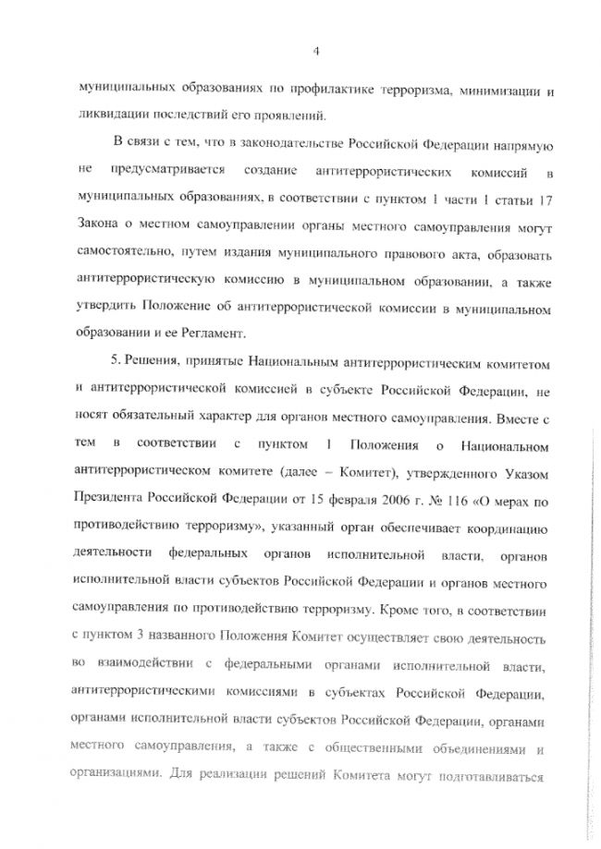](http://грибановский-адм.рф/tinybrowser/fulls/images/photo/2020/11/11/18/27_page-0004-1.jpg)

[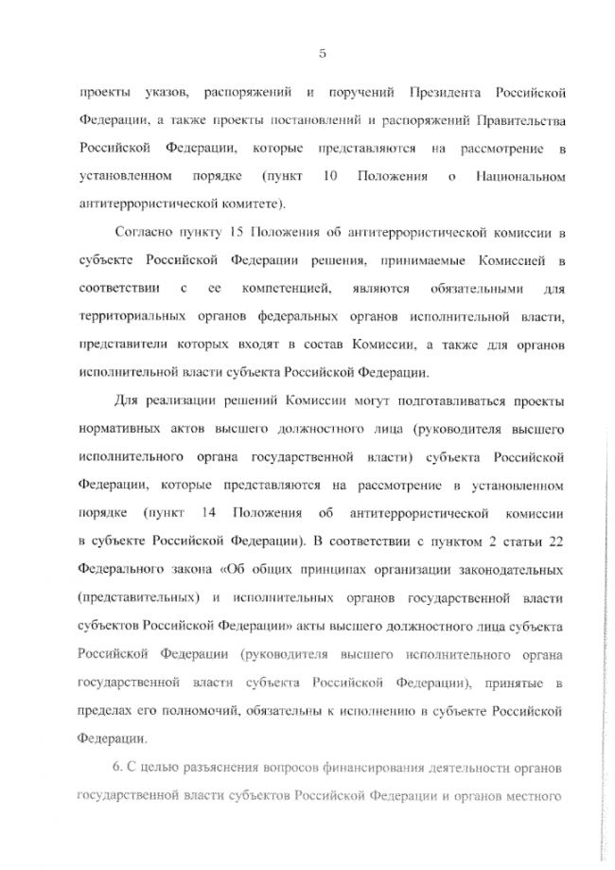](http://грибановский-адм.рф/tinybrowser/fulls/images/photo/2020/11/11/18/27_page-0005-1.jpg)

[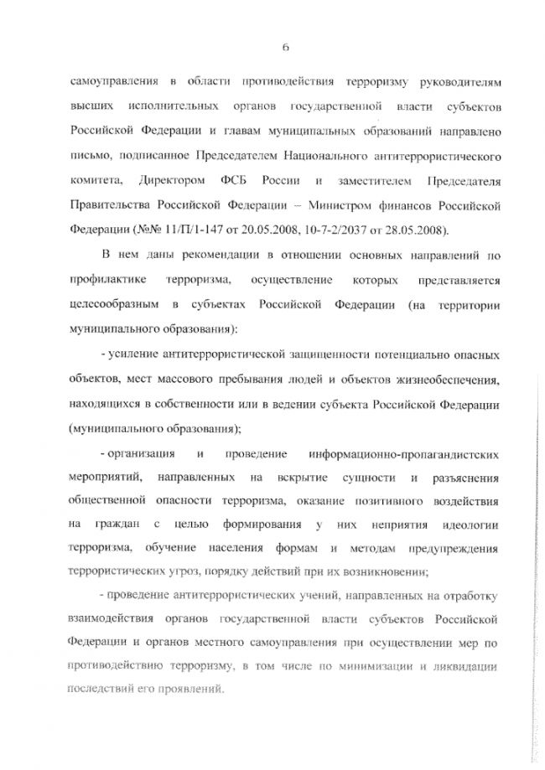](http://грибановский-адм.рф/tinybrowser/fulls/images/photo/2020/11/11/18/27_page-0006-1.jpg)

[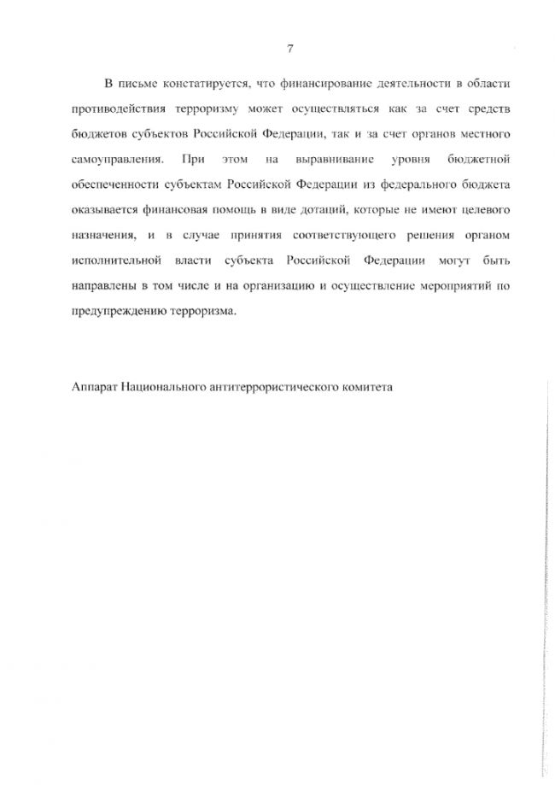](http://грибановский-адм.рф/tinybrowser/fulls/images/photo/2020/11/11/18/27_page-0007-1.jpg)