[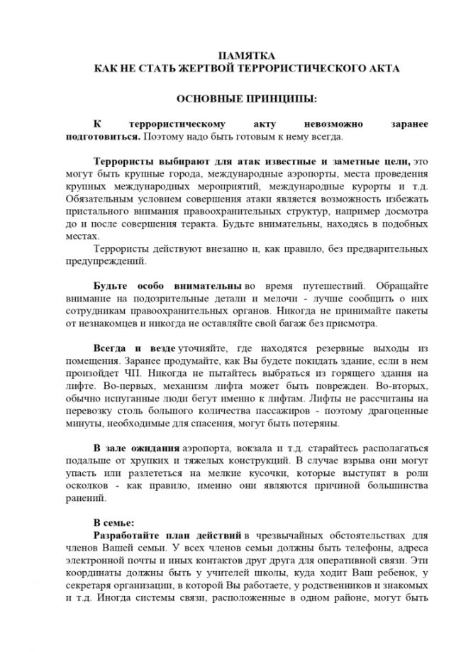](http://грибановский-адм.рф/tinybrowser/fulls/images/photo/2020/11/11/17/10_page-0001.jpg)

[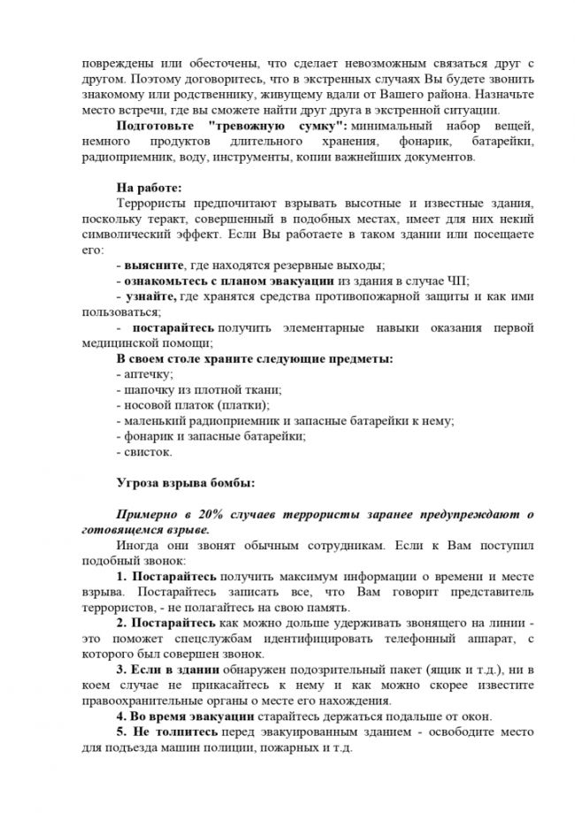](http://грибановский-адм.рф/tinybrowser/fulls/images/photo/2020/11/11/17/10_page-0002.jpg)

[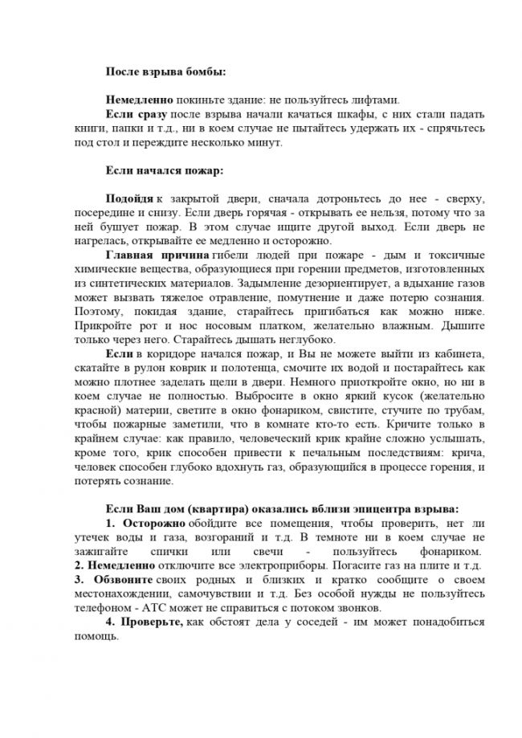](http://грибановский-адм.рф/tinybrowser/fulls/images/photo/2020/11/11/17/10_page-0003.jpg)

[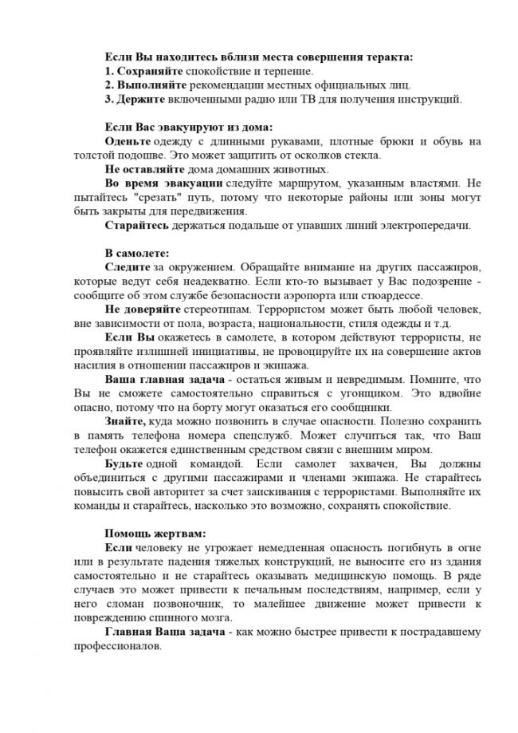](http://грибановский-адм.рф/tinybrowser/fulls/images/photo/2020/11/11/17/10_page-0004.jpg)