[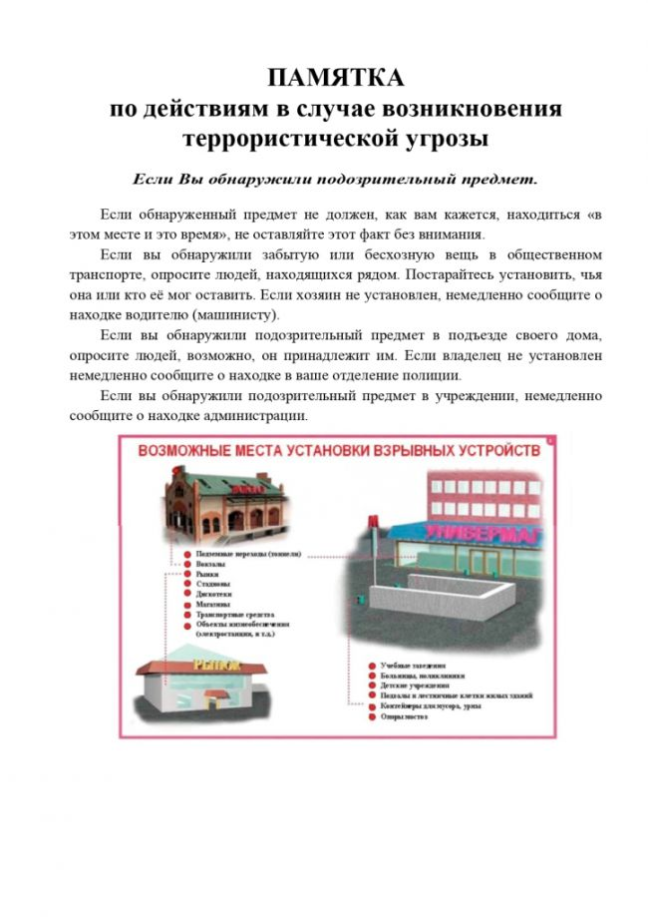](http://грибановский-адм.рф/tinybrowser/fulls/images/photo/2020/11/11/17/21_page-0001.jpg)